PRODUCT REQUIREMENTS DOCUMENT

Rising India Hackathon 2.0
  - QR Team Check In and Meal Redemption
V1 implementation handoff • 10 November 2026 • Organizers and Codex

Product and launch scope
Rising India Hackathon 2.0 needs a single record of team entry and meal service across concurrent volunteer stations. Plan for about 350 teams over two event days. Each team presents one reusable QR pass. A volunteer scans it, verifies the team and the requested service, then explicitly confirms. Supabase returns the authoritative outcome. Two stations may scan the same team at the same time, and the app must record only one successful claim for the same entitlement.
Primary users. An event administrator configures the roster, event calendar, station assignments and entitlements, monitors progress, and handles exceptions. A volunteer operates an assigned checkpoint from a phone. A participant presents a printed or phone-displayed team pass and has no staff account.
Release scope. Include staff sign-in, event overview, team import and management, team QR issuance and reissue, locked volunteer checkpoints, scan and confirm, duplicate and error states, live totals and history, admin corrections, schedules, and reports and backup procedures. Support an authenticated responsive web app with desktop-oriented administration and phone-oriented scanning. Use the selected designs and authenticated real data at launch.
Out of scope for this release. Participant registration and accounts, individual meal balances, payments, judging, push notifications, native apps, and offline digital redemption or sync. Treat an app-install prompt, automated delivery to team leads, and extra dashboards as separately approved enhancements.

Staff permissions
Capability | Admin | Volunteer
Overview and reports | Event-wide filters, history and authorized export | Progress and recent activity for assigned day and checkpoint
Teams and passes | Validate import, maintain roster, issue or replace passes, approved export | Scan and view minimum team information. Scoped lookup only if approved
Record entry or meal | If enabled, use the same confirmation flow at an authorized station | Preview and confirm only at the assigned station
Volunteer accounts and schedules | Provision or disable accounts, set checkpoint assignments, manage event windows | View assignment, active service, and window
Correct actions and recover passes | Reason-required corrections and reissue. Review audit log | Escalate to admin

Use individual staff accounts with an organizer-owned allowlist. Disable self-enrollment. An admin assigning a volunteer selects the day and checkpoint. The volunteer sees a locked badge and no control to switch modes or dates. An assignment change is explicit and audited. Every protected request rechecks the active membership and assignment so a revoked account or a reassigned device loses its previous privileges on the next request.

Team pass and checkpoint flow
1. Prepare the roster. Use the existing registration dashboard as the source. Process approved registrations through a scoped adapter with stable source IDs. Provide an admin CSV fallback with required-field, category, roster and duplicate validation, a dry run, and explicit batch commit. Preserve team IDs, current pass versions and claims when updating roster metadata.
2. Issue and distribute. Generate one QR per accepted team automatically for reuse across permitted services. Provide an admin batch run to issue any missing passes and download current passes as PNGs or a print-ready PDF. Include a readable team code for support and deliver each pass privately through the team lead. A team code identifies a record and carries no QR authority.
3. Ready to scan. Show service, local day, window, connection, locked assignment, current totals and last server-confirmed success. The operator deliberately opens the camera. Pause decoding after a candidate frame, release the camera when leaving the scanner, and offer a clear camera permission recovery path.
4. Preview. Resolve the pass online. Present service and day, team code and name, college, individual members’ names, category, roster size, and the prior status or eligibility result. Eligible previews show a service-specific confirmation button and a Cancel or Scan Again action. A camera frame, lookup, modal dismissal, and navigation each leave the service record untouched.
5. Confirm. The volunteer verifies the displayed team and service. For Lunch and Dinner the volunteer checks that every registered team member is present together and attests to this through the explicit confirmation action. Disable the button while waiting. The server revalidates actor, assignment, QR version, team, eligibility, window and uniqueness in one transaction. Staff admit or serve on a verified, active success receipt.
6. Recover or continue. Show existing completion time for an authorized duplicate and suppress confirmation. Give each other blocked outcome a plain-language recovery action. After success or a terminal error, provide Scan Next Team. Reset all state from the preceding scan before reopening the camera.
Operator sees | Result and next step
Ready or eligible | Scan QR or review and explicitly confirm the named service
Confirmed | Show team, day, service, local time and receipt reference. Update counts from the server
Already recorded | Show original local time within the actor's authorized scope. Stop and route disputes to admin
Unknown, revoked or ineligible pass | Clear preview. Rescan or route to help desk. Reveal only the minimum authorized information
Closed window, wrong assignment or expired preview | Show the next permitted action. Require a new online preview after a change
Offline before submit | Pause scans and disable confirmation. Restore connection or escalate to event lead
Connection lost after submit | Show verification pending. Resolve the original request online before service or a fresh attempt

Seven operational safeguards
Control | Required behavior
S1 Locked roles | Admin provisions staff and controls checkpoint/day assignments. Server checks role and assignment on every request. Assignment changes invalidate stale previews.
S2 Database duplicate protection | One active service claim per team and canonical entitlement. The database arbitrates concurrent requests. Same-request retries return the original receipt.
S3 Audit and correction | Record actor, time, action, event scope, service and linked outcome. Admin reverses or corrects through a reason-required action. Preserve the original row and correction link.
S4 Connection failure | Require server verification before admitting a team or serving a meal. Hold uncertain submissions for resolution. A manual incident process requires organizer approval and later reconciliation.
S5 Lost QR reissue | Admin verifies team identity using the event's approved method and records a reason. Atomically revoke old token and issue its successor. Existing service claims stay attached to the team.
S6 Schedules | Evaluate server time against the configured local event schedule. Fail closed for missing, disabled or closed windows. Record admin edits and invalidate affected previews.
S7 Backup and export | Admin can export event records and reports. Infrastructure owner runs encrypted recoverable backups, rehearses restore in isolation, and keeps a recovery checklist and custodian list.

Live progress history and reports
The overview shows Entry, Lunch and Dinner cards with confirmed count, eligible count and percentage for the selected scope. Show remaining with the service and scope named. Use distinct eligible team entitlements as the denominator and active successful claims as the numerator. For an eligible total of zero, show zero eligible and an em dash for the percentage. Across services, label the rollup as completed service entitlements. Distinct teams checked in and meals served are separate measures.
Admin searches the roster by team code, name or college and filters history by event day, checkpoint and category. History uses cursor pagination sorted by server time and stable record ID. Include team code and name, category, checkpoint, actor, result, and local time where authorized. Admin can open the original action and linked correction. Volunteer history and last-success stay within the station scope, with minimal team fields. Corrections refresh progress and preserve the historical trail.
The Live badge requires a recent successful server refresh. Show last refreshed time, stale state after missed refreshes, and reconnection status separately from claim status. A successful write refreshes its station immediately. Poll other views while visible and refresh on reconnect or focus. For consistent exports, record generation time, applied filters, timezone, and field definitions. Keep signed reports or archived copies within the approved retention period.

Event day and category policy
Configure two named event days with their actual dates and local time zone, Asia/Kolkata. The approved screenshots contain conflicting example dates and times. The event lead publishes the authoritative schedule. A service has a stable identity for its event, day and checkpoint. Adjusting hours or replacing a QR preserves that identity and prior claims.
Checkpoint | Day 1 | Day 2
Entry in blue | Confirm opening, closing and team-presence rule | Confirm whether repeat Entry is required and the associated window
Lunch in amber | Confirm window and eligible categories | Confirm whether offered. If offered, confirm window and eligible categories
Dinner in purple | Confirm window and eligible categories | Confirm whether offered. If offered, confirm window and eligible categories

Registration categories. The selected light Lunch reference labels A as Outside Nagpur, B as Nagpur (Non-NIT), and C as NIT Students. Use these as display labels pending roster-owner verification. The registration dashboard supplies the actual category. Category drives reporting filters and the configured eligibility rule for each checkpoint and day. A category letter alone gives no entitlement. At launch, publish an explicit allow or deny value for each A, B and C cell of each enabled service. Block unknown categories, inactive teams and missing rules. Any change to a team category is reasoned and audited, and triggers a fresh preview before confirmation.
Team-wide meals. Lunch and Dinner each require the full registered team to be physically present together. One confirmed action redeems that service for the team. An incomplete team returns when complete. Use registered member count as the serving quantity snapshot if the organizer wants headcount reporting. Never offer partial or individual redemption in V1. Entry also requires visual verification and explicit confirmation. The event lead sets the physical presence rule for Entry.
Time and duplicate keys. Evaluate opening and closing on the server. An enabled window accepts requests from its opening instant up to but excluding its closing instant. Store times in UTC and show IST with the selected event day. If a window crosses midnight, use its configured service day and keep the assignment and duplicate key attached to that day. The key is one active claim per event, team, day and checkpoint. A different allowed service or day uses a distinct key. At approximately 350 teams, six enabled day and checkpoint combinations would allow up to 2,100 successful team actions, subject to category eligibility.
Publishing and changes. Start with draft days and disabled services. Prevent publication with missing category cells, ambiguous date assignment, invalid window times or overlapping versions of the same service. Use explicit admin edits with a reason and revision. Changes affect future previews, and historical claims keep their category and service snapshots. For reporting, use the published eligibility matrix and report historical completions separately if roster or policy edits move a prior claim out of the current eligible population.

Selected interface references
The eight PNGs attached to the user's final selection in AI Identity Answer are the design baseline. Treat the light Event Overview and light Lunch flow as the shared surface and hierarchy references. Use navy or teal framing, warm white cards, soft borders, rounded panels and checkpoint-specific accents where the selected screens show them. Preserve selected dark sidebars, camera views, purple Dinner framing and other local treatments with their light content cards. Exclude the later all-dark redesigns. Build accessible web components and omit the illustrated device frames, operating system status bars and sample camera imagery.
Ref | Exact source filename | Implementation mapping
UI-01 | Rising India Hackathon Dashboard-1.png | Admin Event Overview. Three-logo masthead, left navigation, day and category filters, live/last updated indicators, three checkpoint cards, a remaining card, overall and checkpoint progress, recent scanning history and quick actions. This is the desktop visual baseline.
UI-02 | Hackathon QR Check-In Admin Dashboard-2.png | Complementary admin overview. Add the checkpoint filter, operator column in history and quick access to each safeguard. Fold these into UI-01's light working surface and shared navigation.
UI-03 | Rising India Volunteer Check-In Dashboard-3.png | Blue Entry station. Header and online state, progress and remaining counts, large Open Scanner action, last confirmed team and visibly locked assignment. Keep scan history and profile reachable. Team Lookup routes to the restricted lookup/help flow, with privileged recovery reserved for admins.
UI-04 | Rising India Lunch Check-In App Showcase-4.png | Lunch flow companion. Preserve the framed camera, confirmation card, explicit confirm action, success and duplicate outcomes, and recovery affordance. Replace the mockup’s offline queue with the verified recovery flow. Keep individual member names in the authorized confirmation view only.
UI-05 | Hackathon Lunch Check-in Dashboard-5.png | Amber Lunch station. Warm light body, assigned scanner strip, progress panel, large scan action, last successful check-in and compact bottom navigation.
UI-06 | Neon Purple Dinner Check-in Dashboard-6.png | Purple Dinner station. Retain its deep purple header and navigation accents, light stats and action cards, card order, and purple progress, scanner action and assignment badge.
UI-07 | Rising India Lunch Check-In UI Mockup(1).png | Canonical light scan journey. Top row shows station home, camera and team confirmation. Bottom row shows success, duplicate with original timestamp and category progress with recent activity. Adapt the pattern for Entry and Dinner using their own accents and copy.
UI-08 | Rising India Hackathon Operations Dashboard-8.png | Admin operations detail. Use the assignment and schedule panels, seven safeguards, searchable team records, recent audit activity, export actions and backup status. Present these as overview links or detail views to keep UI-01's hierarchy.

Shared interface rules
- Admin uses a responsive sidebar and compact filters for Event Day, Team Category and Checkpoint, with a visible connection and freshness indicator. Collapsing desktop navigation must leave every authorized action reachable.
- Volunteer uses a phone-first layout. Place the station, connection state, locked assignment and scan action ahead of supporting information. Standardize bottom navigation on Home, History and Profile. Where shown, Team Lookup and My Station are secondary actions or read-only information. A checkpoint label or chevron never grants a different station.
- Use blue with a door icon for Entry, amber with cutlery for Lunch and purple with a moon or dinner icon for Dinner. Use text and a distinct icon for each checkpoint and outcome. Reserve green for success or online status and red for a blocking result, with copy that distinguishes duplicates, errors and recoverable connectivity issues.
- Camera view shows the checkpoint, framing guide and close/back control. Where supported, offer torch and camera switching. A repeated decoder frame must leave one confirmation card open. The card puts event day, station, team ID, team name, institution, category, member names, member count and eligibility before the confirm action. Cancel returns to scan mode. Show success only after server confirmation. A duplicate shows its original recorded time and a Scan Next Team action, with the confirmation action unavailable.
- The mockups contain inconsistent dates, names, counts, times, summary formulas and status claims. Use configured event days, schedule and measured database totals. Use “Remaining for Lunch” or another explicit checkpoint label where the design says “Remaining Teams.” Across checkpoints, label sums as checkpoint completions and opportunities, with unique-team totals displayed separately.
- Treat any mockup claims about queued scans, offline success or automatic sync as copy to replace. Use an offline or unverified state with Retry and admin escalation. An optional camera import icon requires an approved operational policy and device testing.

Brand asset mapping
Placement | Asset and production mapping
Top left | Rising India Hackathon 2.0. Map the exact recovered PNG from the final three-logo upload, ChatGPT Image Nov 10, 2026, 06_55_47 PM.png, to rising-india-hackathon-2.png. The transparent 1536 × 1024 source is embedded in the brand reference gallery.
Top center | Nagpur Institute of Technology. Map the recovered user-provided NIT Shield Crest with Laurel and Ribbon(2).png to nit-crest.png, pending final asset approval.
Top right | Team Nexus. Map the recovered user-provided Futuristic Neon Team Nexus Emblem(1).png to team-nexus.png, pending final asset approval.

Use the same ordered, subtly sized logo lockup on admin and volunteer views. Keep each mark's aspect ratio, transparency, intrinsic colors and clear space. Set the app name to Rising India Hackathon 2.0. Use the organizer-approved event logo on the generated QR pass, separated from the readable QR code and its quiet zone. Label each informative logo for assistive technology and suppress repeated decorative copies. Sign off all three source files by visual comparison before the production release.

Secure architecture
Use a responsive HTTPS web app for the admin and volunteer views. The browser decodes QR frames locally and sends a validated token only in the body of an authenticated request. Supabase Auth supplies individual staff sessions. Postgres owns check-in state, schedule and category checks, receipts, and audit. The existing registration dashboard is the source for the approximately 350 teams. Use React and TypeScript as the proposed client baseline, with Cloudflare Pages as the planned HTTPS host. Confirm the QR library, registration transport and staff sign-in method during implementation. Pin the selected versions and commit the lockfile.

Trust boundaries
- Deploy with a Supabase project URL and publishable key in the browser. Keep secret or service-role keys, database credentials, and backup credentials in operator-controlled environments. Keep staff provisioning out of the browser. Disable public signup and anonymous sign-in. Provision and rehearse access before the event. If invitations, OTP, or password resets rely on email, configure an approved sender and test delivery to volunteer addresses. Supabase's default SMTP restricts recipients and rate, so it is unsuitable for event onboarding. Auth configuration · SMTP
- Authorize every RPC against a current event_staff record keyed by auth.uid() and event. Enforce assignment scope where used. User profile fields, UI routes, and cached roles confer no authority. Disabling membership blocks the next call even with an unexpired token. Validate live session identity for sensitive writes. Pair sign-out with local context removal, and deactivate departed staff immediately. Protect admin accounts with MFA and require the stronger session for admin mutations and exports. Sessions
- Expose only the api schema in the Supabase Data API. Keep base tables and privileged functions in ops, an unexposed schema. Explicitly revoke browser DML and broad function execution, including default PUBLIC function execution for migration owners. Allow authenticated to execute named api wrappers only via the Data API. Use invoker wrappers and grant only the private helper execution and schema usage needed to dispatch. Put event, role, and actor checks inside each private privileged helper. Set search_path = '', qualify every object, and assign narrowly privileged non-login function owners. Enable RLS on application tables as defense in depth and permit only the intended internal roles and predicates. Review migrations and run Security Advisor and direct-API denial tests. API security · RLS · Function security
- Set a restrictive content security policy and allow camera access only on the app origin. Validate input lengths and formats, rate-limit lookup and mutation by signed-in actor, and restrict authentication redirect origins. Never put raw QR tokens, JWTs, or participant data in URLs, analytics, server logs, or cached pages. Keep result payloads to operational fields. Restrict access to roster files, logs, and exports and apply the organizer-approved retention period.
Bootstrap admin memberships through a controlled operator path. Admins can manage volunteer assignments but the assignment API cannot create or promote administrators. Deny access without an active event membership and bind volunteer scope to its assigned day and checkpoint.

Data model and integrity
Use UUIDs for internal identifiers, stable roster codes for operator lookup, UTC timestamptz for time, and the event's Asia/Kolkata time zone for display and schedule entry. Scope records to an event and use composite foreign keys where needed to reject cross-event or cross-team links. Generate event-day labels from configured event dates. Include immutable server creation timestamps and actor IDs for operational records.
Entity | Key fields and constraints
events, event_days | Event ID, name, timezone, lifecycle. Configure two event days with calendar dates and display labels. Unique date and day number within event.
service_windows | Stable ID, event day, mode (entry, lunch, dinner), open and close instants, enabled, revision. Unique event/day/mode. Require opens before closes.
service_rules | Window ID and category A/B/C, eligibility flag, optional narrower hours and quantity rule. Unique window/category. Validate category hours inside window.
event_staff, station_assignments | Event ID and Auth user ID identify membership, fixed role, active status and display label. At most one active assignment per volunteer and event binds the user to a service window and revision.
teams, team_members | Event ID, stable external registration ID, normalized team code, display name, college, category, registered size, active status and revision. Member rows hold stable source ID or ordering and display name. Restrict names to authorized roster and preview queries.
team_qr_tokens | Event and team, unique token hash, version, issued/rotated by and at, expiry and revocation. Partial unique index for one unrevoked token per team. Retain an encrypted pass artifact for authorized download while the version is active.
scan_previews | Opaque ID, actor and session, event, team, token version, service window, team/window/rule revisions, proposed quantity, expiry and consumed time. Short-lived and private.
claims | Event/team/window, confirmed at/by, station if used, QR version, category and quantity snapshots, full-team presence attestation for meals, effective status, source (scan or manual), linked preview or incident and command. Partial unique index on event/team/window where status is confirmed.
command_receipts | Unique event, actor, operation and request UUID. Store normalized input fingerprint, final result code, claim reference if applicable, and committed time. No raw QR.
incident_records | Event and service scope, controlled paper reference, verified team and occurred-at time, reconciliation status and admin decision. Access is restricted to assigned administrators.
audit_events | Append-only event scope, actor, server time, action, entity ID, reason and bounded before/after fields. Grant operational functions INSERT only for this table. Exclude token secrets and roster exports.

An event/day/mode retains its ID when the hours or eligibility change, so rescheduling cannot grant a second claim. Use server time and a half-open window, open at the start and closed at the end. Resolve category eligibility from the roster and configured rule each time. Missing, disabled, or incomplete rules block confirmation. Prevent rule edits from silently changing what earlier claims represented by keeping category and confirmed quantity snapshots. Audit schedule revisions and make stale previews refresh. Use team row locks for roster changes that affect eligibility or quantity. If later requirements add multiple same-mode serving windows, decide whether they share an entitlement before extending the model.
Index event/team code, QR hash, memberships and assignments, and history by event and newest server timestamp with ID tie-breaker. Add service-window/status indexes for aggregates and verify plans with realistic event data. Use migration files, separate production and development data, deterministic fixture seeding, and generated client types. Pin and verify the CLI version and intended target before dumping or applying remote migrations. CLI target behavior

Registration intake
Upsert confirmed registrations by stable external team ID and event. Validate the source schema, normalized code, college, member list, category, and active status. Report conflicting code/ID mappings before activation. The first accepted registration automatically creates the team's single initial QR. Retries or roster updates preserve the team ID, current QR version and claim history. Deliver the initial QR through the approved registration dashboard flow. Persist only a digest for validation and an authenticated-encrypted pass payload for controlled generation and download. The adapter commits issuance atomically with the accepted team so a crash before delivery can be retried without a second issuance. Limit decryption to the server-side pass export path, use an independently stored key and record downloads. Keep any integration credential server-side, limited to roster intake and initial issuance. Provide an admin CSV import and validation path if the dashboard cannot supply a direct integration for the event.

API and transaction contracts
Publish typed request and response schemas in the repo. The following signatures are design contracts. Identifiers are UUIDs unless noted, times are ISO 8601, and filters and limits are allowlisted. API wrappers derive the actor from the session. Mutating calls accept a client-generated request UUID, scoped to one explicit staff action. Never accept a client-supplied actor, category, entitlement, confirmation time, or success state.
RPC and inputs | Result and access
get_context(event_id) | Authorized role, station scope, event days, current windows, server time. Staff.
preview_scan(event_id, window_id, qr_payload) | For an authorized match, team code/name, college and member names, category, quantity, day, mode and decision. Eligible matches receive a short-lived opaque preview_id. No attendance or meal claim.
confirm_claim(event_id, preview_id, full_team_present, request_id) | Committed claim receipt or typed refusal. Staff in scope. Requires a valid preview and explicit confirmation. Lunch and Dinner also require a positive full-team presence attestation.
get_command_status(event_id, operation, request_id) | Own durable result or NOT_VISIBLE. Authorized admin resolves another actor's event receipt through restricted audit lookup.
get_stats(event_id, day_id, mode, category) | Counts, scope, server snapshot time. Staff within permitted scope.
search_teams(event_id, query, category, cursor, limit) | Admin search by code, team name or college. Return minimal fields. A volunteer help route can use exact team code and station scope if approved.
list_history(event_id, filters, cursor, limit) | Sanitized newest-first rows, stable next cursor and snapshot time. Staff within permitted scope.
void_claim(event_id, claim_id, reason, request_id) | Original claim retained with void metadata, reasoned audit event and receipt. Admin.
rotate_qr(event_id, team_id, reason, request_id) | Active version and receipt after atomic replacement. Admin downloads the new pass through the scoped export path. A replay returns the original receipt.
import_roster(event_id, batch, commit, request_id) | Dry-run validation or atomic commit with audit. Reject duplicate codes, invalid categories and roster/size mismatches. Admin. Apply equivalent checks in the registration adapter.
save_schedule(event_id, changes, expected_revision, reason, request_id) | Atomic revision update or conflict. Admin.
assign_station(event_id, user_id, window_id, expected_revision, reason, request_id) | Update volunteer assignment or deny. Admin.
update_team(event_id, team_id, changes, expected_revision, reason, request_id) | Validate admin scope and permitted roster corrections. Update atomically and invalidate prior previews. Preserve the stable team ID, QR and history.
reconcile_incident(event_id, incident_id, window_id, team_id, occurred_at, reason, request_id) | Admin-only review and recording after documented manual service. Requires an approved incident, scoped evidence, valid prior window and the same unique claim key.
Admin pass and report endpoints | Typed POST for selected team IDs or report filters. Validate admin role and generate authorized PNG/PDF passes or CSV. Log export scope and use no-store responses.

Confirmation and retries
1. Require a positive preview and show the team name, college, individual member names, day, action, category, and quantity before the operator clicks Confirm. Each scan may start a preview. Meals require a positive operator attestation of the complete team. The server records the attestation and derives the quantity from the verified roster. Only a deliberate click or equivalent keyboard action may call confirm_claim. Cancel and switching day or mode discard the client draft. The server's short preview lifetime is proposed at 60 seconds. A preview is bound to its actor, session, team, QR version, and exact service window.
2. Recheck current role and station access. Serialize same-key requests with a unique receipt reservation in the same transaction. If a receipt already exists and its input fingerprint matches, return the original result and its current effective claim status, even when the original preview has expired. A claim voided in the meantime must display as voided and block handoff. Reject a reused key with different inputs. Exclude transient infrastructure failures from terminal business results.
3. For a new request, take locks in a documented order. Lock the staff/assignment and event configuration for a consistent read, then the team row, then the preview. Configuration edits and assignment changes take the corresponding exclusive locks. Claim, roster changes, and QR rotation serialize on the team row. Under lock, recheck preview binding and freshness, active token and team, unchanged revisions, eligibility, and service window using database time. A stale or closed preview requires a new scan and confirmation after the issue clears.
4. Insert the claim subject to the partial unique index. A competing request at another station receives ALREADY_CONFIRMED with a scoped prior-claim timestamp. Save the claim, preview consumption, audit event, and command outcome atomically. Roll back on infrastructure or audit failure. The index is the last line of duplicate protection even if two clients both saw valid previews. Unique partial indexes · Conflict handling
5. Render definitive success only from a committed CONFIRMED receipt. Show plain-language states mapped to typed codes for INVALID_QR, QR_REVOKED, WINDOW_CLOSED, INELIGIBLE, PREVIEW_EXPIRED, CONTEXT_CHANGED, ALREADY_CONFIRMED, FORBIDDEN, and retryable transport failure. Keep sensitive diagnostics out of the UI. Never reuse a request UUID for another team or action.

Disconnects and ambiguous results
If disconnected before confirmation, disable Confirm and label any old stats with their last refresh time. If a click times out or the response is lost, show Pending verification and keep the same opaque request ID tied to the original intent. Hold admission or meal handoff while verification is pending. After reconnect, query the receipt. NOT_VISIBLE can mean a transaction is still in flight. A deliberate retry with the same request ID resolves it safely and either returns the original committed result or applies current checks to the original preview. Clear the pending state only with a terminal result or an admin-led resolution. Retain only the opaque event, preview and request IDs in same-tab session storage for reload recovery, scoped to the signed-in actor. Exclude background write queues, automatic resubmission, and cached approvals. If service must continue through an outage, follow the organizer-approved manual incident procedure and reconcile centrally before reopening affected stations.

Corrections and lost QR
Voiding a confirmed claim requires an admin reason, explicit confirmation, and a transaction that records the status transition, actor, and original values. Never hard-delete the original claim or edit its quantities. A replacement claim follows the same eligibility, time window, fresh human confirmation, and database uniqueness rules. Keep one active confirmed claim for the entitlement. Resolve wrong teams or quantities as a void and replacement where rules permit, with visible links and audit history. Physical service already delivered is a separate operational decision for the incident lead.
Generate each QR as a versioned opaque value from a cryptographically secure random source with at least 128 bits of entropy. Encode no roster fields. Store a hash for validation. Keep a separate authenticated-encrypted payload for controlled pass generation and download. Keep keys outside the database, audit downloads, and recheck the active version before rendering an export. On reissue the admin verifies identity, records a reason, and atomically revokes the old token and installs the replacement while holding the team lock. The server rejects confirmation from a preview minted with the revoked token even if the scan preceded the reissue. Both tokens point to the same team and entitlement history. If delivery fails, allow the admin to retrieve the active version again. Rotate only for a verified loss or exposure. Invalidate cached pass artifacts and revoke access to the old encrypted payload when replacing a pass.

Stats, history, and export
Derive totals from effective confirmed claims scoped to event, day, action, and selected category. Count teams separately from admitted people or meals, using the confirmed quantity snapshot for the latter. Label units on every metric and keep voided rows in history with a void label. History and stats exclude individual member names. For current progress, intersect confirmed team entitlements with the eligible roster under published service rules. Report historical completions outside current eligibility separately to avoid totals over 100 percent. Return snapshot time and an empty percentage when no team is eligible. Refresh after successful writes and poll a small scoped aggregate and recent history while visible. A 5-second starting interval is proposed for rehearsal. Back off on errors and when hidden, and refetch on reconnect. If push is added later, send scoped invalidation signals and fetch authoritative data from the RPCs.
Allow admins to download filtered claims and audit CSVs with explicit timezone, scope, stable IDs, statuses, quantities, reasons, and an export timestamp. Use CSV quoting and neutralize spreadsheet formulas in text cells. Capture exports from a consistent snapshot, omit token hashes and unnecessary personal data, and audit who exported which scope. A CSV is the operational report. A separate encrypted logical database dump, migration set, and documented Auth/role recovery are the restore assets. Rehearse restoration into a separate environment and validate counts, revoked tokens, permissions and login. Use a pre-event backup, event checkpoints at least at service boundaries and often enough for the agreed recovery point, and a final archive. Back up the encryption key separately with its own custodian and test pass recovery. Confirm the required recovery point and restoration time before go-live. Supabase backup guidance

Performance and reliability targets
Use about 350 teams as the planning roster. Rehearse with at least 500 synthetic teams, their member rows, both event days, all three checkpoints and a representative history. The following are proposed release targets. Confirm peak device count and test on the venue network before committing to capacity.
Measure | Proposed release target
Camera start | Within 2 seconds at p95 on representative phones after permission is granted
Preview and confirm | Each within 1.5 seconds at p95 on the venue's primary connection during a 10-minute test with 20 signed-in devices and 10 requests per second across polling, scanning and confirming
Remote progress freshness | Within 10 seconds of a committed operation while the overview is visible and connected. Local station refreshes on receipt
Duplicate and audit integrity | Exactly one active claim after simultaneous submissions for the same key. Every successful write has one linked audit event
Recovery drill | Recover event records from an encrypted dump, reconcile the latest export or incident log, and demonstrate restored totals. Proposed event-day RPO 1 hour and RTO 2 hours, subject to rehearsal and owner approval

Load-test the full path from session and camera through database and dashboard on representative iOS Safari, Android Chrome and desktop admin browsers. Include low light, glare, printed QR, phone-displayed QR, permission denial, device rotation, loss of connectivity before and after submit, expired sessions, and same-team races across multiple devices. Record p50/p95, error rates, retries, active claims and mismatch counts. Inspect slow queries and retain useful indexes on lookup, uniqueness and history filters. Mask pass tokens and participant details in logs and telemetry.

Accessibility
Target WCAG 2.2 AA for staff workflows. Provide keyboard access to all administrative actions, visible focus, properly named controls, dialogs with focus restoration, clear validation, and polite live announcements for status. Use text and icons alongside the checkpoint colors and result colors. Verify 4.5:1 contrast for normal text, 3:1 for large text and meaningful control boundaries, and use 44 by 44 CSS pixels as the preferred touch target size at stations. Test text zoom, 320 CSS pixel reflow, reduced motion, screen reader use, and glare on phones. Use assistive text for logo and QR context and label decorative elements appropriately. Provide an approved online exception route when the camera is unavailable. WCAG 2.2

Acceptance criteria
ID | Given and when | Required result
AC01 | An admin prepares the roster and a duplicate registration ID or invalid category arrives | Show the invalid input. A replay or update does not create a second team or pass.
AC02 | A volunteer scans a valid QR and closes the preview | No active claim, success audit event, or stats change. The preview shows team name, college, member names, category, day and service.
AC03 | A QR is presented at two eligible checkpoints or on two eligible days | Each allowed team, day and checkpoint combination succeeds independently under the signed entitlement matrix.
AC04 | Two different stations confirm the same team and entitlement together | The database commits one active claim. The other response reports duplicate or prior completion. Refresh shows one increment.
AC05 | A confirm commits but its response is lost | Show verification pending. Reconciliation with the original request ID returns the same receipt without incrementing totals.
AC06 | The device goes offline before confirmation | The app holds service, displays offline, and records no queued successful redemption.
AC07 | A volunteer tampers with a URL or request, changes the day/mode, opens admin features, or loses assignment after preview | The backend denies the operation and discloses no out-of-scope data.
AC08 | Server time reaches a window boundary, a service is disabled, or the team category is ineligible | The opening instant is included, the closing instant is excluded, and the closed or ineligible request produces no claim.
AC09 | Admin reissues a lost QR after identity verification | The previous QR fails, including pending previews. The replacement preserves prior Entry and meal claims. The audit event records who acted and why.
AC10 | Admin reverses a mistaken claim with a reason and it is later recorded properly | History preserves the original, reversal and subsequent confirmation. Active counts reconcile. The next confirm still enforces policy and uniqueness.
AC11 | Reports are filtered, a correction occurs, or the connection becomes stale | Counts and history match scoped authoritative rows. CSV is filtered correctly and stale state is visible.
AC12 | Organizer compares each final screen with its matching selected reference | Approved layout and state anatomy match, Entry is blue, Lunch amber, Dinner purple, and the approved event, NIT and Nexus files appear in the correct slots.
AC13 | An administrator runs the event-day export and recovery drill | The export is authorized and usable. An isolated restore reproduces tested teams, claims and audit links with counts checked.
AC14 | Accessibility and venue-device checks run | A keyboard and screen reader user can complete the applicable flows. Smartphone scanners handle denied permission, physical passes, and network recovery.
AC15 | An incomplete team is at Lunch or Dinner | Staff can cancel or return to scanning. Only explicit confirmation with full-team presence records a team meal.

Budget and event day operations
Keep total incremental event infrastructure within ₹2,000–₹3,000. Use Cloudflare Pages with an existing approved domain or the provider subdomain, staff phones, in-app QR decoding and existing organizer delivery channels. The prior planning conversation favored Supabase Pro for the event month. As checked on 10 November 2026, Pro starts at US$25 per month and includes daily backups retained for seven days. Get the actual total in INR including exchange rate, taxes, provider charges and backup connectivity. Purchase requires organizer approval and a fit within the total cap. Cloudflare Pages limits · Supabase pricing
Use one Free project for development or the event only if the venue load test, backup drill and organizer approval support that choice. The Free plan lists 500 MB of database capacity and 5 GB of egress and pauses inactive projects after one week. Confirm the project is active before rehearsal and opening. Budget the actual cost of a backup hotspot on a different carrier, printing and any delivery expenses before selecting the event plan. Provider backups supplement the recovery and export procedure. Supabase pricing · Supabase backup guidance
Before opening. Freeze the signed event and entitlement matrix, validate the source roster and issued passes, run a dry run at each station, verify primary and hotspot connectivity, log in on charged phones, verify production and backup health, make the baseline export and dump, and brief volunteers on escalation, verification pending, duplicate disputes and service handoff.
During service. Assign an admin and a recovery owner. Watch freshness, API failures and checkpoint throughput. On failure, pause the affected station, switch connection where possible, reconcile uncertain requests, then resume with a fresh preview. On a prolonged outage, the event lead may authorize the controlled paper procedure. Restrict the printed roster with team ID, name, college and member names to one designated person per checkpoint. Use one shared register for each affected checkpoint with team ID, event day, service, timestamp, operator and reason. Reconcile uncertain writes first, then match each paper record to authoritative claims. An admin records verified unclaimed incidents through the audited reconciliation flow, which preserves the original time and the same duplicate protection. Apply the organizer’s approved disposal schedule to paper records.
After service. Close windows, review unresolved attempts and manual incidents, export final history and totals, verify the backup, revoke event-only accounts, and archive or delete event data on the approved schedule.

Build sequence for Codex
1. Set up the repository, typed frontend, repeatable environment setup and separate synthetic fixtures. Record the approved design references, logo manifest, source contract and outstanding decisions in the repository. Keep secrets in environment storage and fixtures free of real team data.
2. Build the Supabase schema, Auth membership, station assignment policies, transaction routines, and negative authorization and concurrency tests. Run the tests on a disposable environment before wiring the UI.
3. Integrate registration ingestion and roster reconciliation. Add admin pass generation and distribution handoff, rotation, audit and correction. Verify replay and reissue before pilot issuance.
4. Build the responsive admin dashboard and volunteer shell, then implement the mobile Entry flow from preview to confirmed or blocked states. Reuse the scanner and state model for Lunch and Dinner with their distinct visual tokens.
5. Add live progress, scoped history, schedules, reports and export. Complete device and accessibility checks, event rehearsals, venue performance and restore drill. Obtain visual, operational and budget sign-off before production use.

Open decisions before launch
Decision | Owner to confirm | Implementation dependency
Actual dates and enabled day × service × A/B/C matrix, including Night 1 crossover, if any | Event and catering leads | Load schedule and eligibility seeds before issuing production passes.
Category assignment authority and any approved exceptions | Registration lead | Map the authoritative roster fields and define change approval.
Physical attendance rule for Entry and optional serving-headcount reporting | Event and catering leads | Whole-team attendance is required for Lunch and Dinner. Confirm Entry verification and the reporting units.
Registration system integration and historical imports, pass distribution, replacement identity check | Registration and engineering leads | Agree mapping, source IDs, delivery channel, QR format and controlled fallback.
Admin scan access, volunteer lookup scope, station handoff, account onboarding | Operations and security leads | Decide permissions and provision named staff ahead of the dry run.
Manual exception desk, reconciliation window, backups, data retention and restore owners | Operations and infrastructure leads | Publish event procedure and test ownership and recovery targets.
Brand lockup and visual approval at reference breakpoints | Brand owner | Compare the built interface with the three recovered source marks and selected screens.
Confirmed peak devices, host ownership and full INR cost | Event and infrastructure leads | Set venue load test and approve production spend.

Source and implementation authority
The original conversation records the online architecture, existing registration flow, whole-team meals, and Scan → Verify → Confirm. The eight attached final selections govern visual layout. The approved roster, schedules and brand originals govern production data and assets. Use this PRD’s open decisions to resolve remaining configuration before launch. AI Identity Answer

Reference gallery for the admin overview
The eight selected mockups appear in this gallery. Use the screen mapping for implementation and the event policy for live values and safety behavior.
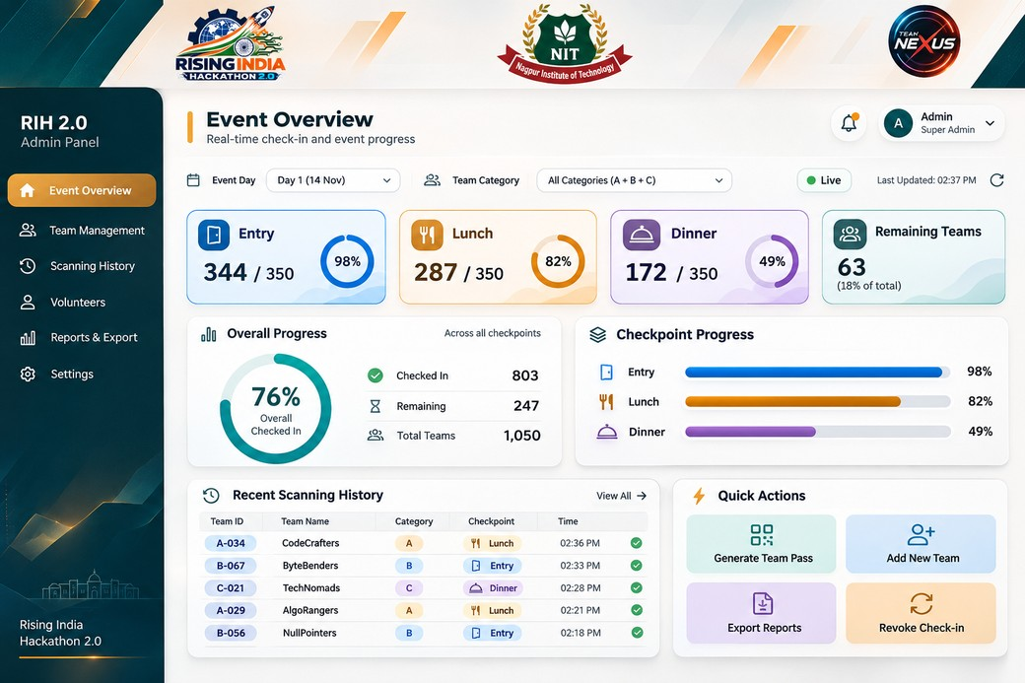
UI-01 Primary Event Overview
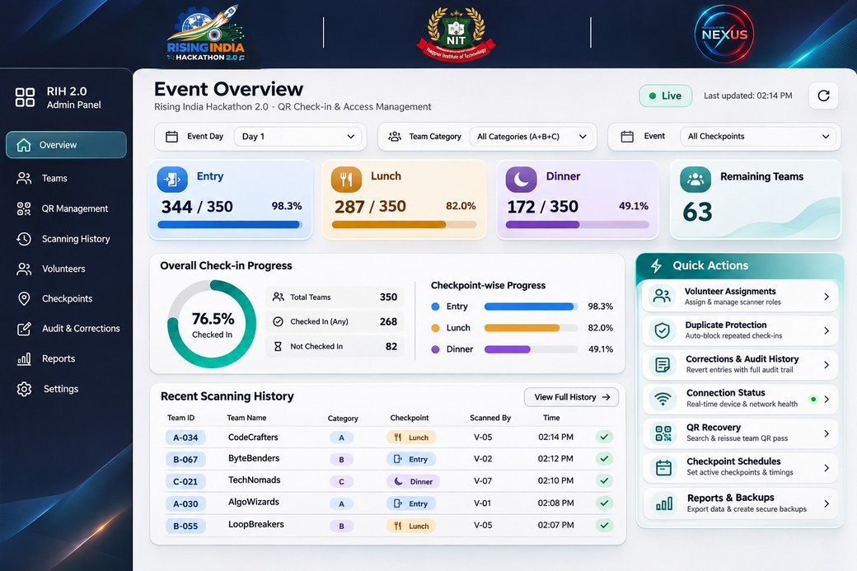
UI-02 Complementary admin layout and safeguards

Reference gallery for admin operations
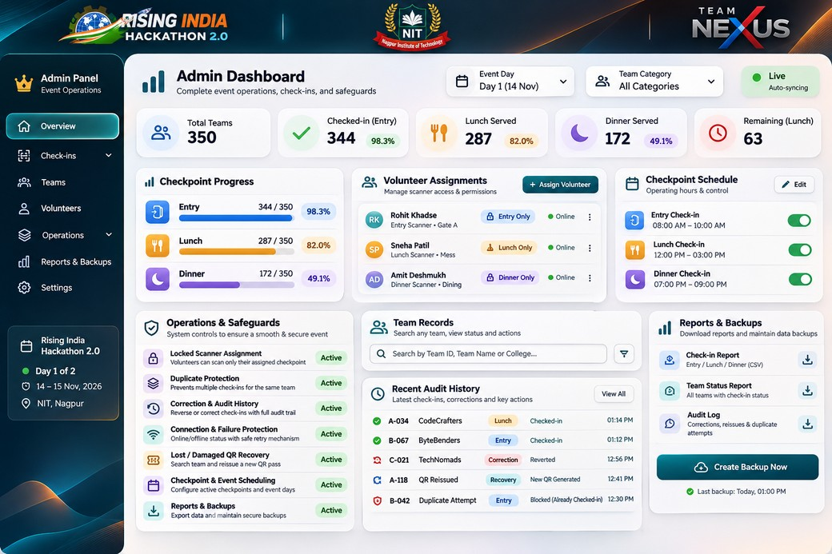
UI-08 Assignments, schedules, audit, and backup controls

Brand reference gallery
These are the original user-provided PNGs. The order below is the required masthead order.
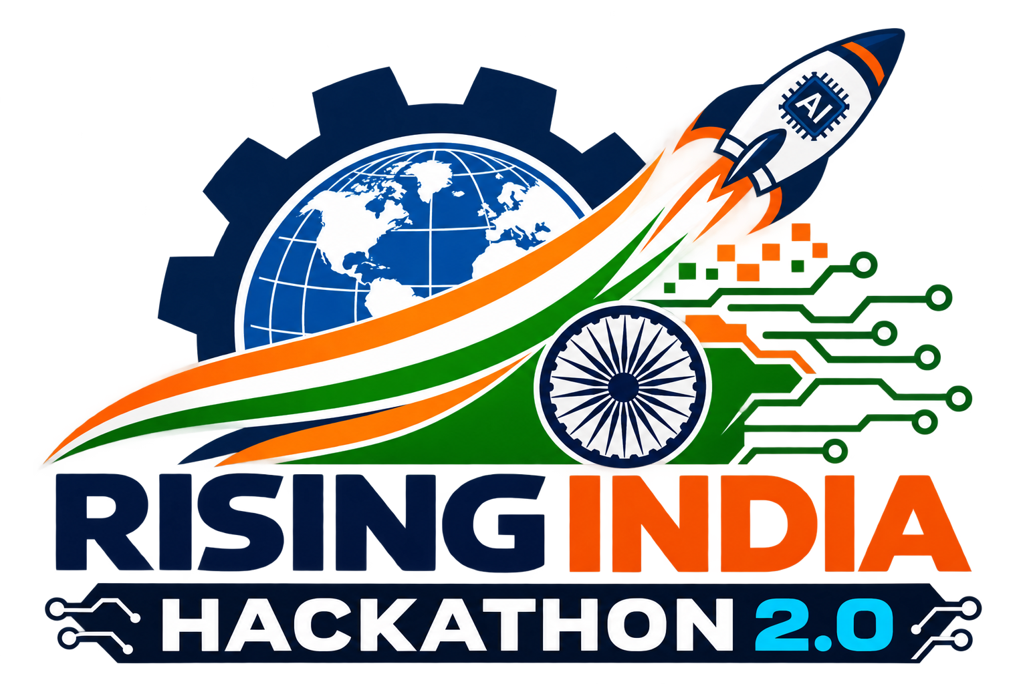
Left Rising India Hackathon 2.0 • Center NIT • Right Team Nexus

Reference gallery for volunteer stations
Entry uses blue, Lunch uses amber, and Dinner uses purple. Keep station identity visible in the header, progress and primary action.
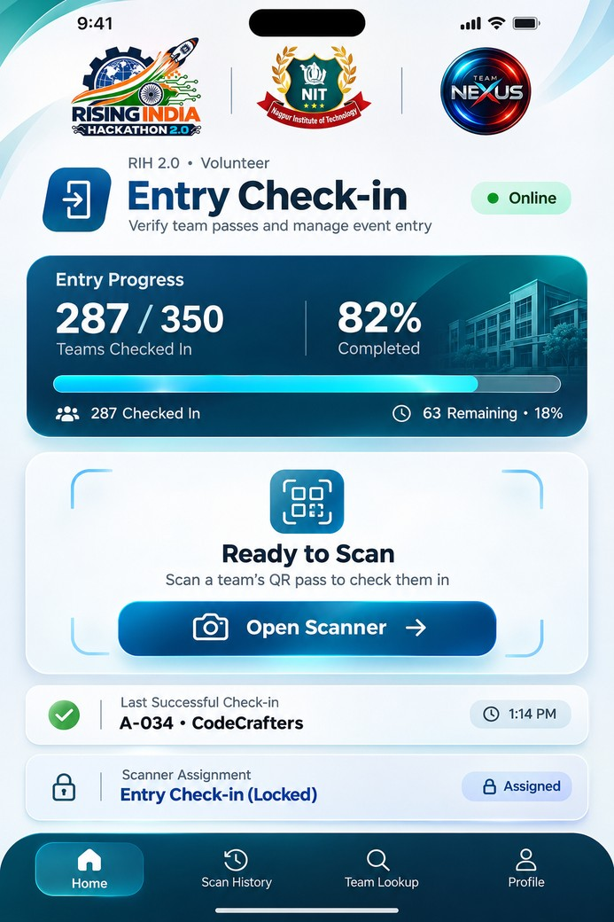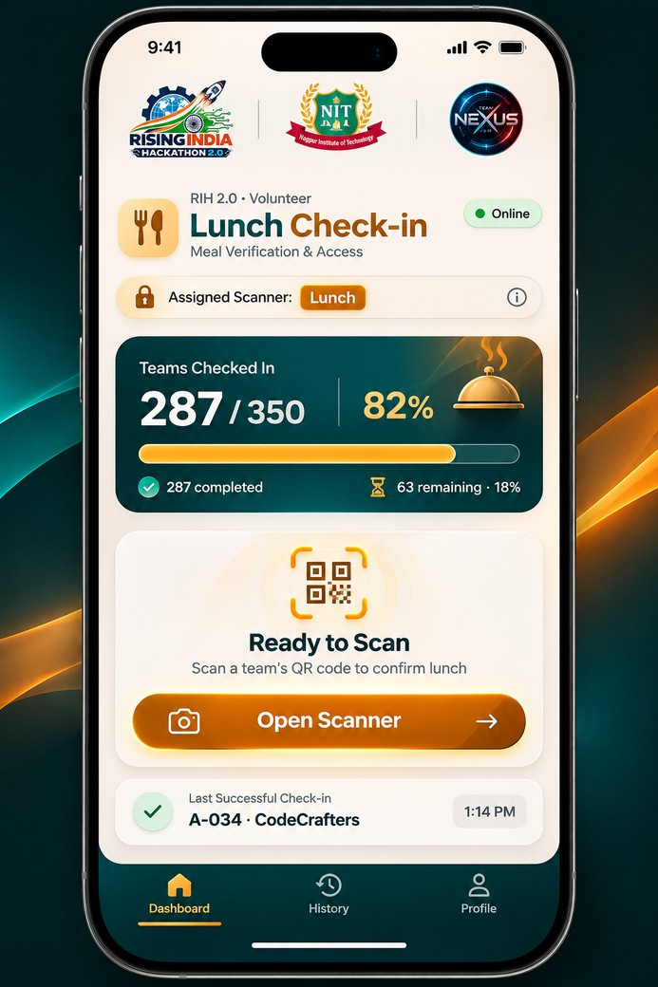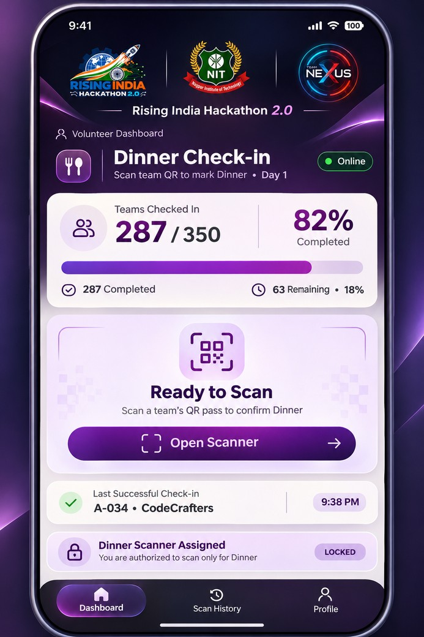
UI-03 Entry • UI-05 Lunch • UI-06 Dinner

Scan and confirmation
Use the light flow for the scan sequence and the companion for camera framing and recovery. Apply the PRD’s connection and verification rules.
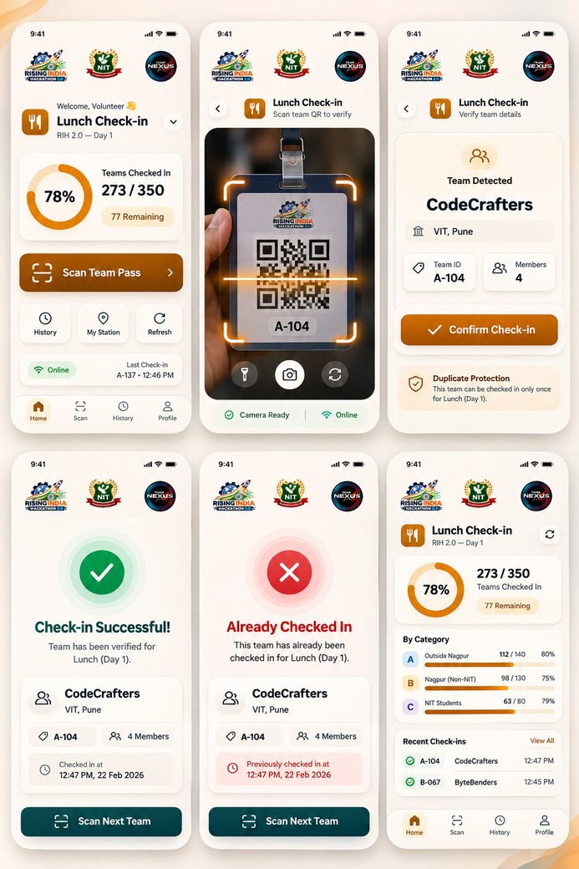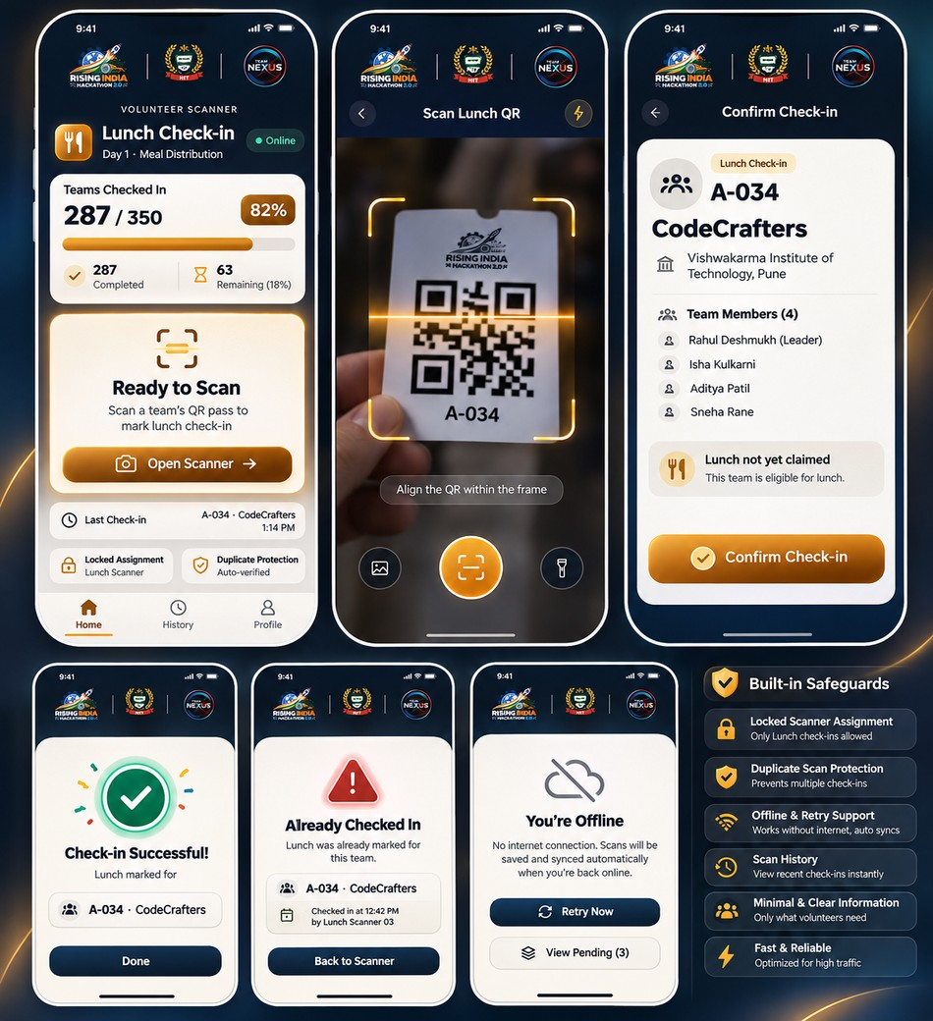
UI-07 Light Lunch flow • UI-04 Lunch flow companion

